|  |
| --- |
|  |
| Technical design |
| *Fasten your seatbelts* |
|  |

ITopiaLogo

*Datum: 22-10-2014*

*Klas: IN-102 team 3  
Versie: 0.2*

*Naam stud: Sjors de Haan // Stud.nr: 500706376*

*Naam stud: Ward v/d Meulen // Stud.nr: 500669712*

*Naam stud: Jasper Nota // Stud.nr: 500700743*

*Naam stud: Talitha Wingelaar // Stud.nr: 500617878*

*Naam stud: Jony Zeitoun // Stud.nr: 500709002*

Contents

Introduction 3

Revisions 4

Project specifications 5

Devices 5

Placement 5

Network design 6

Captive portal 7

DHCP & DNS 9

# Introduction

In this document you will find all technical information regarding the installation of a wireless network inside a Corendon-owned Boeing 737-800. The following information will be discussed in this document:

* Raspberry pi specification
* Device quantity
* Access point location/placement
* SSID name

## Revisions

22-10-2014

* Added revisions table
* Changed database from physical objects to the configuration of the tomcat side
* Information added to device specifications table
* Subject “captive portal” added
* *To-do: change database from physical to digital (tomcat specifications)*

19-11-2014

* Subject protocols removed: *no content*
* Subject Database removed: *no content*

## Project specifications

### Devices

|  |  |
| --- | --- |
| Model | Raspberry pi B/B+ |
| Quantity | 4 B’s |
| OS | Raspbian Wheezy |
| Storage | Minimal 4GB |
| Wi-Fi receiver/transmitter | TP-LINK WL823N |
| Wi-Fi receiver/transmitter speed | 300Mbps |

### Placement

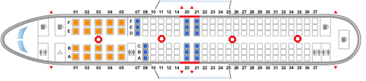

The devices shall be spread throughout the plane as to make sure that every location within the plane has a good connection for the entire flight. The wireless access point will be called ‘Corendon airlines’ and will start off with a captive portal.

|  |  |
| --- | --- |
| Wireless connection name (SSID) | Corendon_airlines |
| Amount of connection points through plane | 4 |

## Network design

In the picture above, you will see the network drawing of this project.  
  
Now follows a short explanation of the network:  
  
Inside the airplane (Boeing 737-800) we’ll place four Raspberry pi’s.  
We have chosen for four Raspberry pi’s, so that all the users have perfect signal strength.   
These Raspberry Pi’s will broadcast a Wireless signal (SSID: Corendon_airlines), of which the user can connect too. The user needs to fill in his boarding number and surname to get access to the internet. If this information is not correct the user gets an error, which will tell the user to try again.

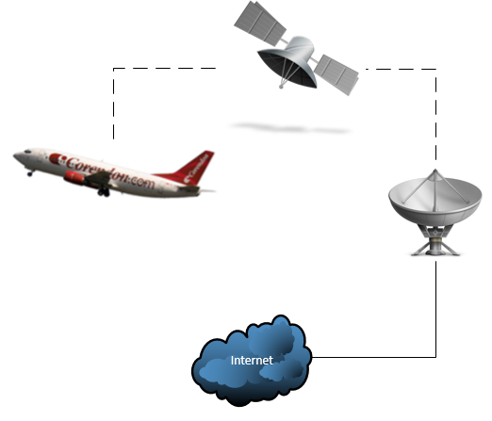

Captive portal  
  
In the picture below you will see an example of the captive portal.

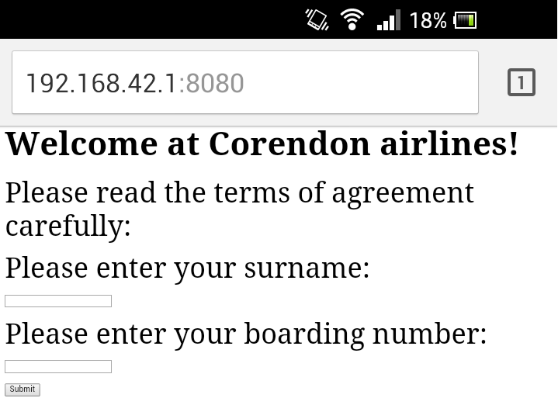  
(This is currently in development)  
The URL in the picture is set to ‘192.168.42.1:8080’, which is the default gateway.  
  
This is what the user sees when the connection with the access point is established.   
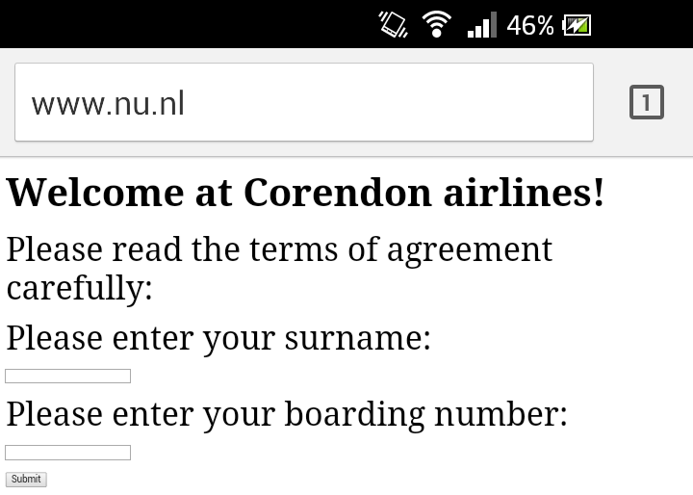  
(This is currently in development)  
As you can see in the picture above is that no matter which URL the users enters, he will be forwarded to the captive portal.  
  
  
The IP tables make an exception when the user clicks on the “Submit” button.  
This allows the user to reach other websites.  
  
  
  
  
Tomcat installation:

To install Tomcat server seven, type in the command below:  *sudo apt-get install tomcat7  
  
sudo apt-get install tomcat7-docs tomcat7-admin tomcat7-examples*Of course we also want an interface for our server:   
*sudo apt-get install default-jdk  
  
sudo apt-get install ant git*Now you want to add an user too your Tomcat server, you can use the command below:   
*sudo nano /etc/tomcat7/tomcat-users.xml  
  
If everything above has gone correctly, you want to restart your tomcat server.  
You can do this with the line below:   
service tomcat7 restart*if everything went correctly; you will now have a working Tomcat server.

## 

## DHCP & DNS

|  |  |
| --- | --- |
|  |  |
| 192.168.42.2 t/m 192.168.42.190 | For all passengers one. |